**ITA0448 – STATISTICS WITH R PROGRAMMING FOR VECTORIZED EXPRESSIONS**

**SUBMITTED BY: DEVADARSHINI J REG NO: 192124092**

**DATE: 23/03/2023**

**1.Children of three ages are asked to indicate their preference for three photographs of adults.**

**Do the data suggest that there is a significant relationship between age and photograph**

**preference? What is wrong with this study?**

**Photograph:**

**Age of child A B C**

**5-6 years 18 22 20**

**7-8 years 2 28 40**

**9-10years 20 10 40**

**(i) Use cov() to calculate the sample covariance between B and C.**

**(ii) Use another call to cov() to calculate the sample covariance matrix for the preferences.**

**(iii)Use cor() to calculate the sample correlation between B and C.**

**(iv)Use another call to cor() to calculate the sample correlation matrix for the preferences.**

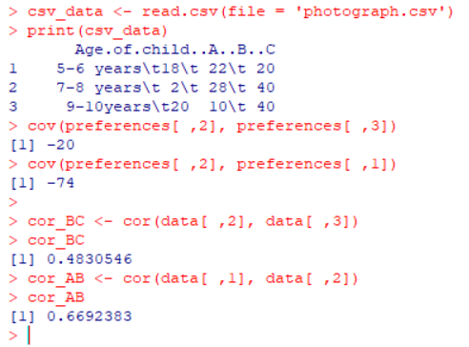

**2.** **Gopal travels daily from his house located at santhom to his office located at OMR road by his car and he wants know how much time he spends on travel. He does record the time taken to reach the off from his home for about a week and has the following value: 46.45, 34.34, 30, 56,12,44.67,43,36.45,48, 35.67, 37.23,32.7,39.20,40.01,45.02,34.12,33.19. Help Gopal to analyse the time data using skewness and kurtosis and give your interpretation.**

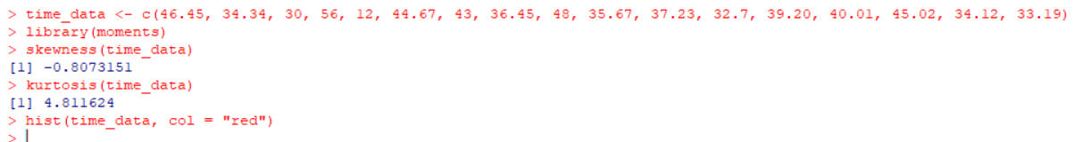 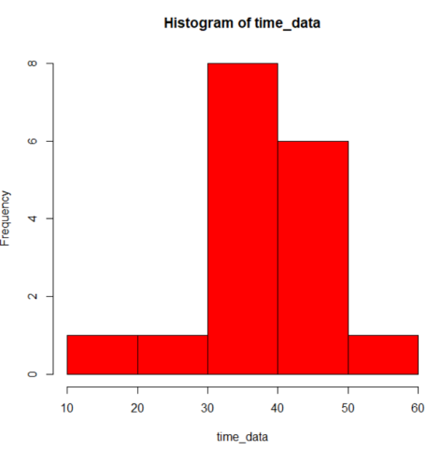

**3(i). Generate a sample of 5000 random numbers and create a normal distribution with a mean value of 70 and respectively fix the Standard deviation to**

**(ii). Calculate the skewness of the normal distribution along with kurtosis and interpret your results.**

**(iii)Write suitable R code to compute the median of the following values.**

**12,7,3,4.2,18,2,54, -21,8, -5**

**(iv) A student recorded her scores on weekly math quizzes that were marked out of a possible 10 points. Her scores were as follows:**

**8, 5, 8, 5, 7, 6, 7, 7, 5, 7, 5, 5, 6, 6, 9, 8, 9, 7, 9, 9, 6, 8, 6, 6, 7**

**What is the mode of her scores on the weekly math quizzes?**

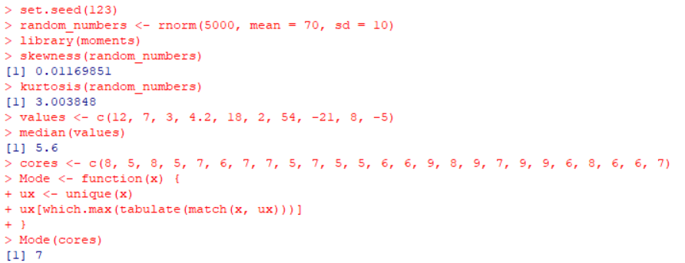

**4. The following table of grouped data represents the weight (in kg) of 100 students. Calculate**

**the mean weight for a student.**

**Weight (pounds) Number of Student**

**21kg 8**

**30kg 25**

**56kg 45**

**73kg 18**

**110kg 4**

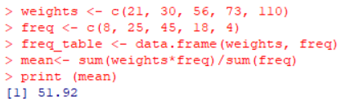

**5.** **Suppose that the data for analysis includes the attribute age. The age values for the data tuples are (in increasing order) 13, 15, 16, 16, 19, 20, 20, 21, 22, 22, 25, 25, 25, 25, 30, 33, 33, 35, 35, 35, 35, 36, 40, 45, 46, 52, 70. Can you find (roughly) the first quartile (Q1) and the third quartile (Q3) of the data?**

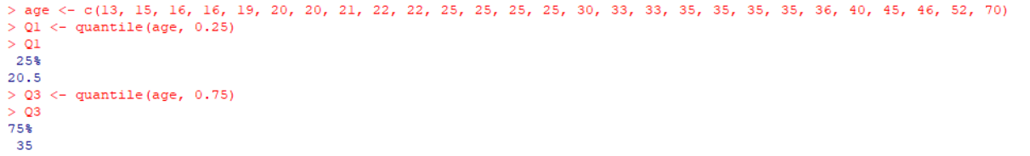

**6. Suppose a hospital tested the age and body fat data for 18 randomly selected adults with the**

**following result**

**age 23 23 27 27 39 41 47 49 50**

**%fat 9.5 26.5 7.8 17.8 31.4 25.9 27.4 27.2 31.2**

**age 52 54 54 56 57 58 58 60 61**

**%fat 34.6 42.5 28.8 33.4 30.2 34.1 32.9 41.2 35.7**

**a. Calculate the standard deviation of age and %fat.**

**b. Calculate the Variance of age and %fat for the above dataset.**

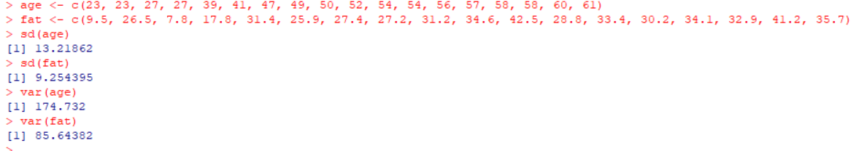

**7. Find the H.M of the values 20.0, 35.5, 40.0 and 37.0 with their respective weights 7.0, 8.5, 3.0 and 6.0**

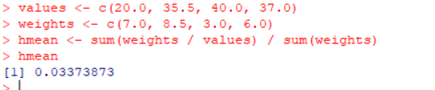

**8. The demand for a product on each of 20 days was as follows, (in units). 3, 12, 7, 17, 3, 14, 9, 6, 11, 10, 1, 4, 19, 7, 15, 6, 9, 12, 12, 8 Calculate arithmetic mean**

